**INTRODUCTION TO COMPUTER NETWORKS**

**LAB 2**

AM.EN.U4AIE22010

ANUVIND M P

**PART 1:**

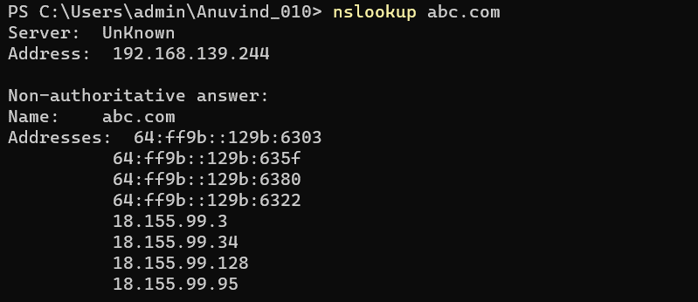

The IP address of abc.com is :

18.155.99.3

18.155.99.34

18.155.99.128

18.155.99.95

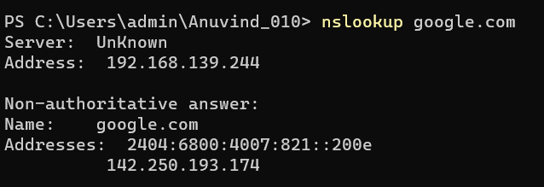

The IP address of google.com is : 142.250.193.174

**PART 2:**

1. Open Packet sniffer [Wireshark] Application and Capture the Wi-Fi/ Ethernet Interface

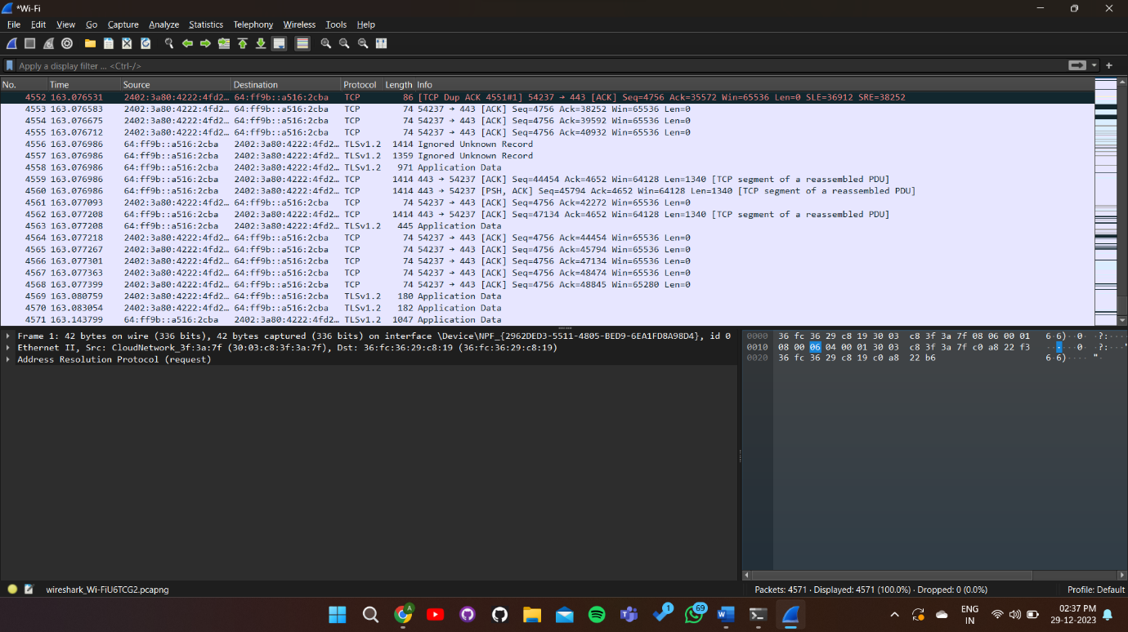

1. Do this activity and capture frames.
   1. Request for a web page by typing the least used URL in the webserver
      * I browsed abc.uk and captured the frames/packets on wireshark

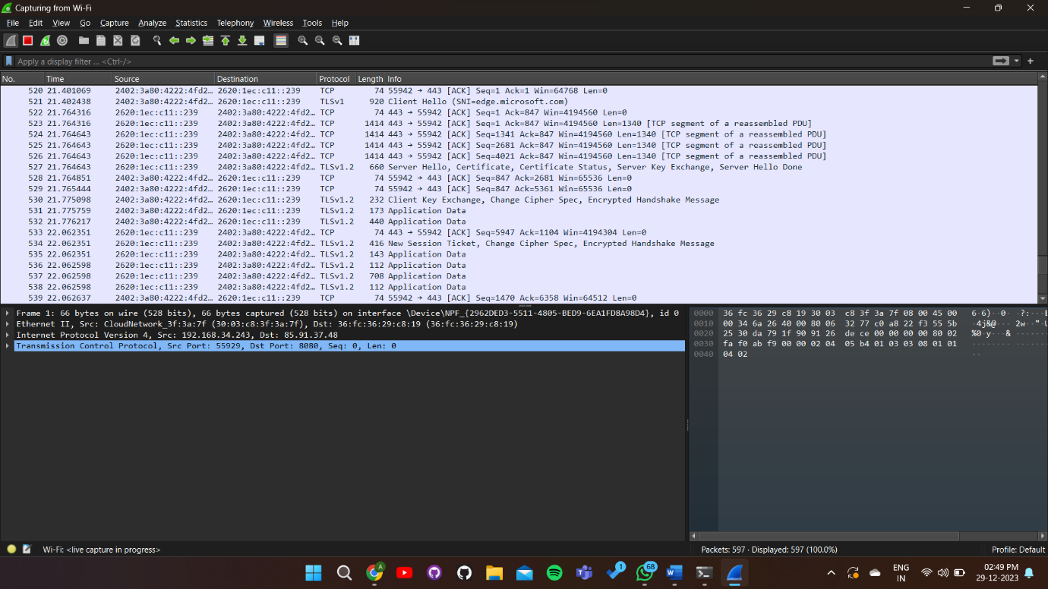

1. Briefly explain the **Encapsulation** process in at least one http request frame of the protocol analyzed. Also complete the table below by PDU contents and details requested in each layer. Also try to provide proof in the form of relevant screenshot

**Ans**: When a request is sent from the application layer, the data(message)can be divided and split into capsules called TCP segments. These segments are further packeted into IP packets which have source and destination address. This is further covered in an ethernet frame which has the source and destination MAC addresses. These packets are now transmitted to other networks by the router. Finally the data converts from electrical signals to optical signals in the physical layer

|  |  |  |  |
| --- | --- | --- | --- |
| Layer | Protocol | Important Contents (You can get details on clicking on a packet) | Purpose of the content specified in the Layer |
| Application | DNS |  | *Encapsulation involves data packaging for specific applications.  *Request Conversion of Domain Name into IP  *Initiates a request to retrieve data or resources from a server |
| Transport | TCP | * Source and destination port numbers, sequence and acknowledgment numbers, flags (e.g., SYN, ACK) | Ensures reliable data transfer | *The transport layer encapsulates data received from the application layer into segments (in TCP) or datagrams (in UDP).  *the data is encapsulated into segments that include headers containing information like source and destination port numbers, sequence numbers, acknowledgment numbers, and control flags.  *Data Communication  *flow control, and error checking |
| Network | ICMPv6 |  | *Encapsulation of Header, Address, Tail, Data into packets  *Facilitates logical addressing and routing across networks |
| Data Link | Ethernet | * Source and destination MAC addresses, frame type (e.g., IPv4) | *Transmit data in the local network  *Facilitates reliable point-to-point communication within a network |